

**EXPERIMENT – 2.1**

**BLINK LED USING BUTTON ON DEV BOARD/NODE**

**What will you learn from this module:**

Blink LED using button on Development Kit/ Node.

**Requirements:**

* nRF connect for desktop software.
* nRF Command line tools.
* Visual studio code.
* USB cable.
* nRF52832 Development Board/Node.

**Prerequisites:**

* Basic knowledge of C/C++
* Basic knowledge of communication protocol.
* Basic project setup.

**Setup and Configuration**:

* Open VS Code and go to **Browse samples [1]** and search **Button [2]**.

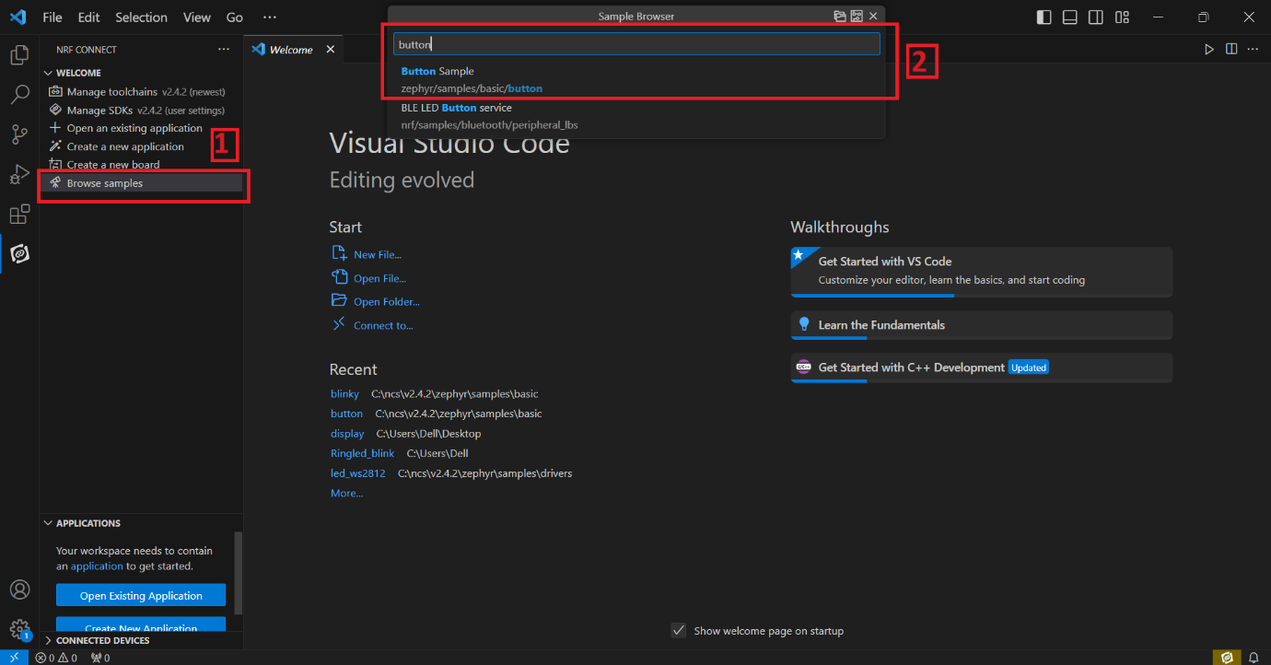

* Click on **Create new build configuration [1]**. Here you can change the board version, if you are using nRF52832, then select **nrf52dk_nrf52832 [2]** or you can change from dropdown menu for another version like nRF52833 etc.
* Click on the Configuration and select **prj.conf [3]** from dropdown menu and then **click on the Build Configuration [4]**.

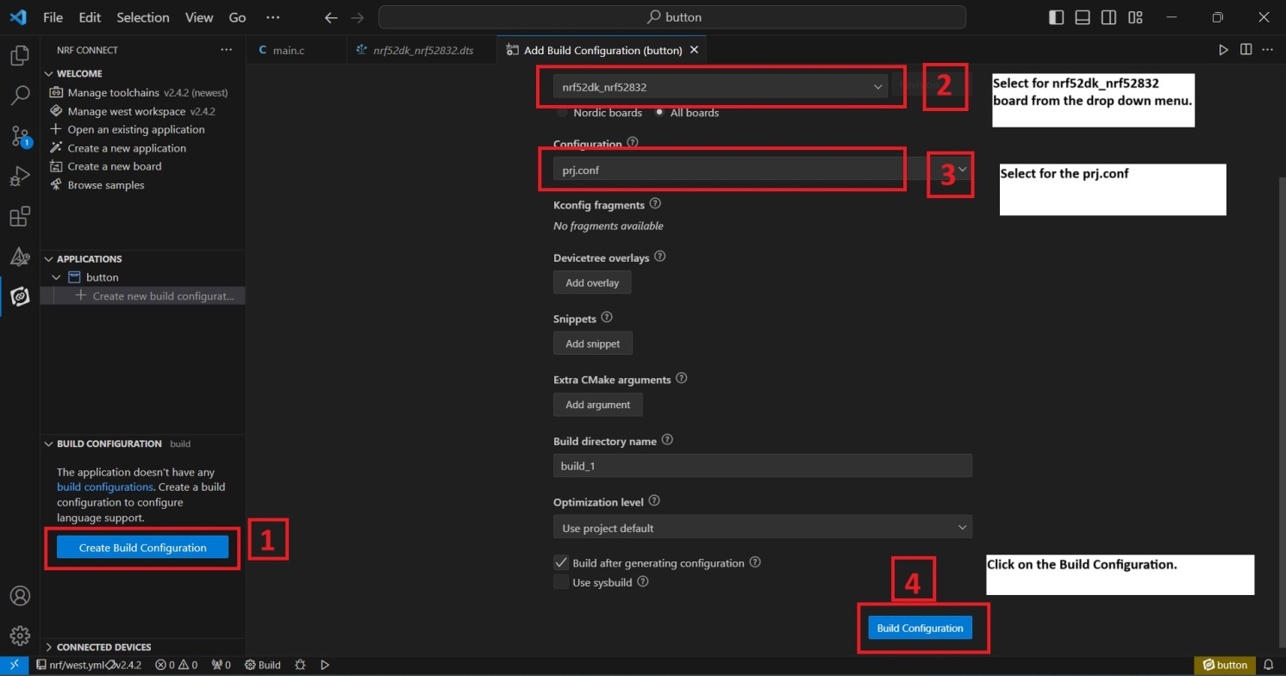

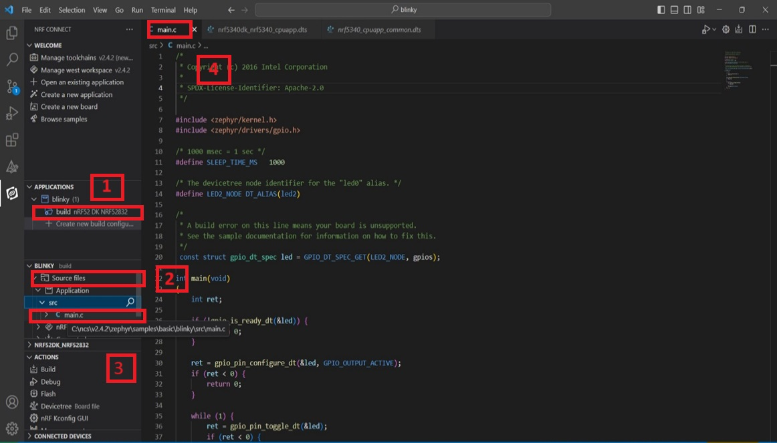

* Go to **source file [2]**, click **source file** > click on **Application** > click on **src [3]** > click on **main.c [4]**.
* By clicking on **main.c** file and you will see the code on your screen.

* Click on **Build [1]** configuration again and check the **CONNECTED DEVICES [2].**
* If device id is visible, then **Flash [3]** the code in Development Kit.
* If **flashed successfully [4]** message is displayed on serial terminal, then flash process is complete.

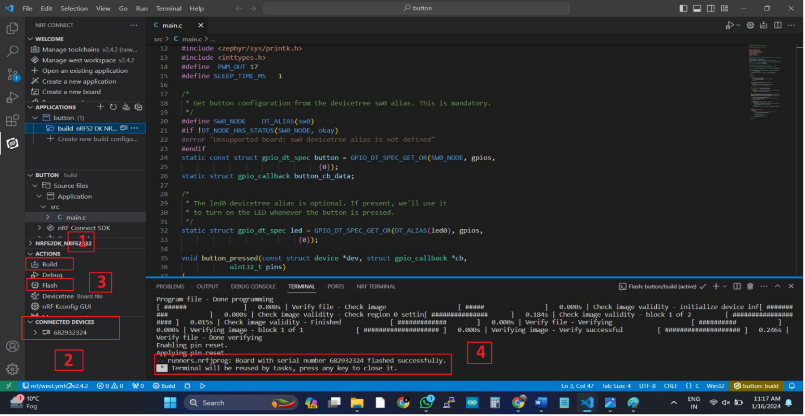

* **OUTPUT**
* nRF52832 board after press the button.
* nRF52832 board Before press the button.

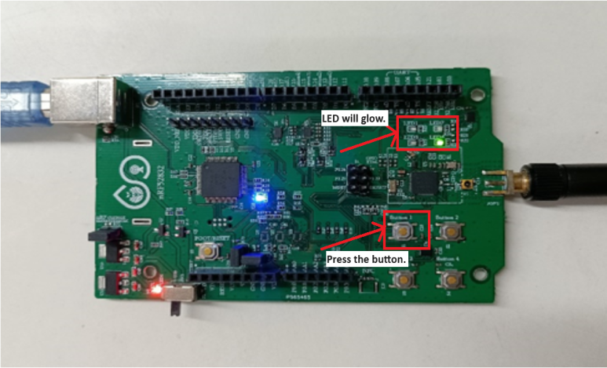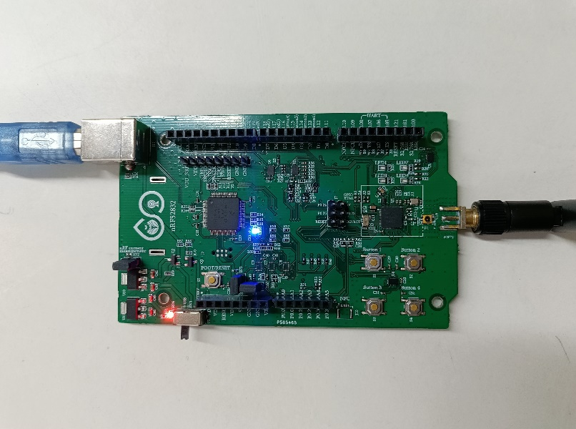

* **With the help of NODE**
* For Node programing remove the jumper **J2** from the development board.
* Now flash the code with the help of nRF52832 development board as shown below in the figure.

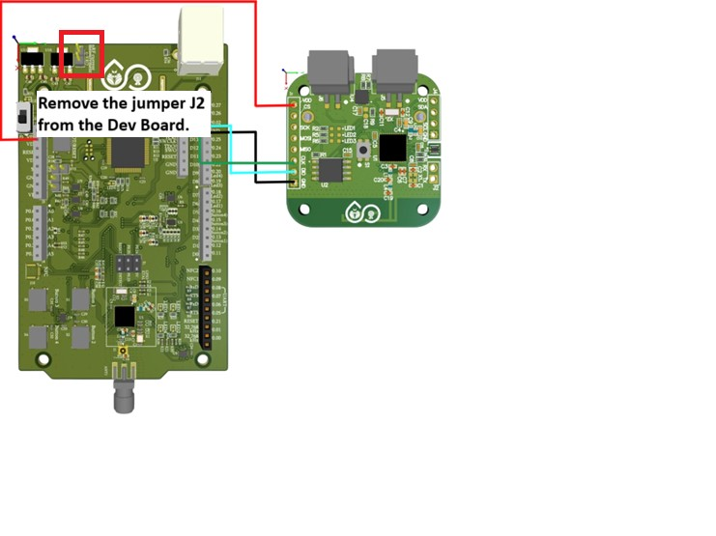

**Board Pins -> NODE Pins**

**VDD(3.3V) -> VDD**

**GND -> GND**

**CLK -> CLK**

**DIO -> DIO**

* There is another way of flashing the code with the help of Node Programmer as shown in the picture below.

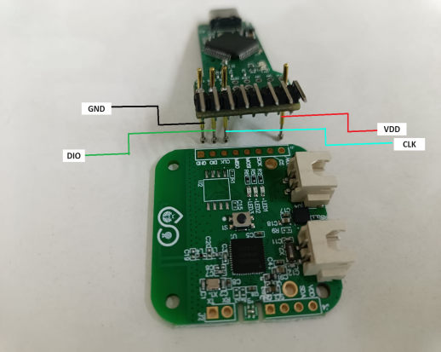

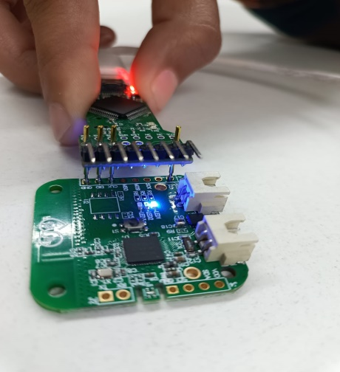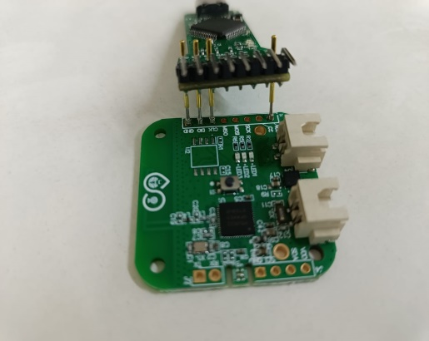

* NODE after program.
* NODE with connection.
* NODE without connection.
* **OUTPUT**
* Node board before press the button.

* Node board after press the button.

